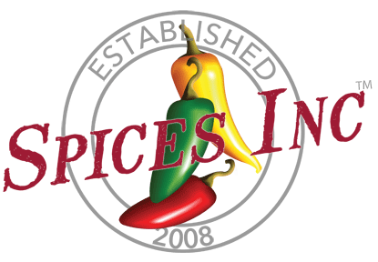

Food Safety Reporting Structure Statement

Spices, Inc. is committed to producing safe, legal, and high-quality food products in compliance with regulatory requirements and the SQF Fundamentals Code. Senior Management accepts ultimate responsibility for the development, implementation, and continuous improvement of the Food Safety Management System (FSMS).
The Chief Operations Officer (COO) serves as Senior Management and is accountable for ensuring that the Food Safety Management System is effectively implemented, maintained, and supported with adequate resources. The COO also serves as the SQF Practitioner and Preventive Controls Qualified Individual (PCQI) and has overall authority for the Food Safety Plan, validation and verification activities, and management review.
The Quality Assurance Manager is responsible for the daily implementation and verification of food safety programs, including Good Manufacturing Practices (GMPs), monitoring activities, internal audits, corrective actions, and product disposition. The Quality Assurance Manager has the authority to place product on hold, stop production when necessary, and escalate food safety concerns directly to Senior Management.
Food safety reporting operates independently from production and commercial functions. Food safety decisions shall not be overridden by operational, financial, or revenue considerations. All employees are responsible for reporting food safety concerns to their supervisor, the Quality Assurance Manager, or directly to Senior Management without fear of retaliation.
Spices, Inc. ensures that clear reporting pathways are maintained so that food safety issues are communicated promptly and addressed effectively. This governance structure supports transparency, accountability, and continual improvement of the Food Safety Management System.
This policy is reviewed at least annually by Senior Management as part of the Management Review process and revised as necessary.

Signed,

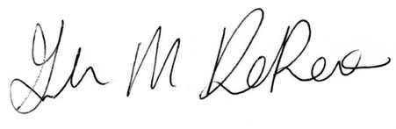
_________________________
Glenna Depoe
Chief Operations Officer
December 08, 2025

